1. 
2. How to give a method name to test method so that it is meaningful.  
   **Solution**: Suppose, if you want to test **truncateAInFirst2Positions**(),   
   then the method name should be **“test”** + **“methodNameToBeTested”**   
   => **“test”** + **“TruncateAInFirst2Positions()” 🡺 testTruncateAInFirst2Positions()**
3. 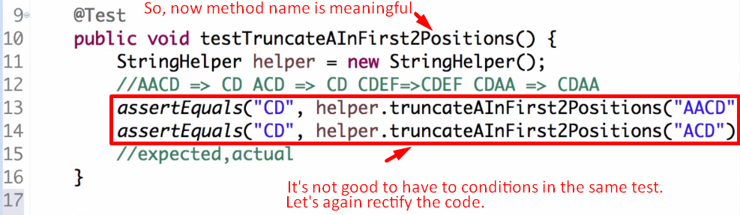
4. **NOTE**: Test Method should be **public void** otherwise error.
   1. **Why**? Some frameworks call test methods and **they are in different packages**.
5. What if we want to test the same method for more than one condition:  
   **Solution**: Suppose, if you want to test **truncateAInFirst2Positions**(),   
   then the method name should be   
   **Template**:   
   **“test”** + **“methodNameToBeTested”** + **“_ConditionToBeTested”  
     
   Condition 01**:  
   🡺 **“test”** + **“TruncateAInFirst2Positions” + “_AInFirstTwoPositions”  
   testTruncateAInFirst2Positions_AInFirstTwoPositions()  
   Condition 02  
   🡺 “test”** + **“TruncateAInFirst2Positions” + “_AInFirstPosition”  
   testTruncateAInFirst2Positions_AInFirstPosition();**

**NOTE**: As earlier, we didn’t have annotation **@Test**, so, we usually prefix test method with “test”.  
But now we have @Test, so no need for the prefix.

1. 